# 1 .I NTRODUCTION

# OVERVIEW

Salesforce is the World’s number one customer relationship management CRM platform.

Its help in marketing sales, service, commerce and IT teams works as one from anywhere

in the world. This can help field sales teams ensure that order fulfilled quickly and accurately and that inventor levels are maintained at optimal levels.

# PURPOSE

It aims to produce are time knowledge of the saleforce and how can we build a app using salesforce in this project we build a candidate result card application for educational, which would be useful for the staff to reduce time and track the performance of the student with case. It is helpful to have large number of data maintained under own platform.

# 2. PROBLEM DEFINITION &DESIGN THINKING

EMPATHY MAP

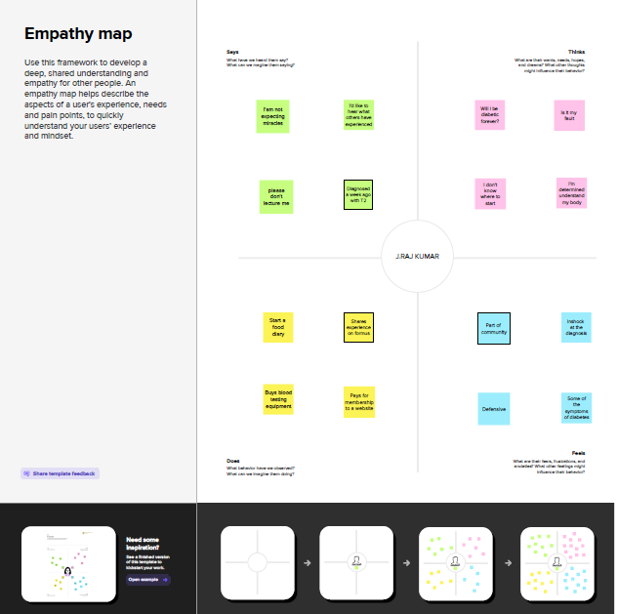

V.Sridhar

IDEATION & BRAINSTORM MAP

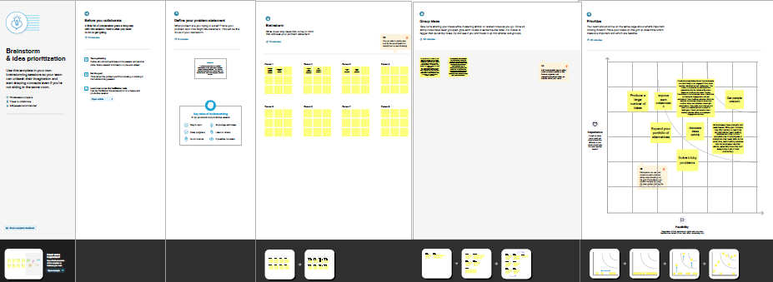

# 3. RESULT

|  |  |
| --- | --- |
| Object Name | **Fields in the object** |
| kkkkjj SEMESTER | |  |  | | --- | --- | | Fields Label | Data Type | | Semester Name | Text | | Course (lookup) | Text | |
| COURSEDETAILS | |  |  | | --- | --- | | Fields Label | Data Type | | Course Name | Text | | Course ID | Text | |
| I INTERNALSRESULTS | |  |  | | --- | --- | | Fields Label | Data Type | | Candidate ID | Text | | Course ID | Text | | Marks | Text | |

# Milestone-1: Creation Salesforce Org:

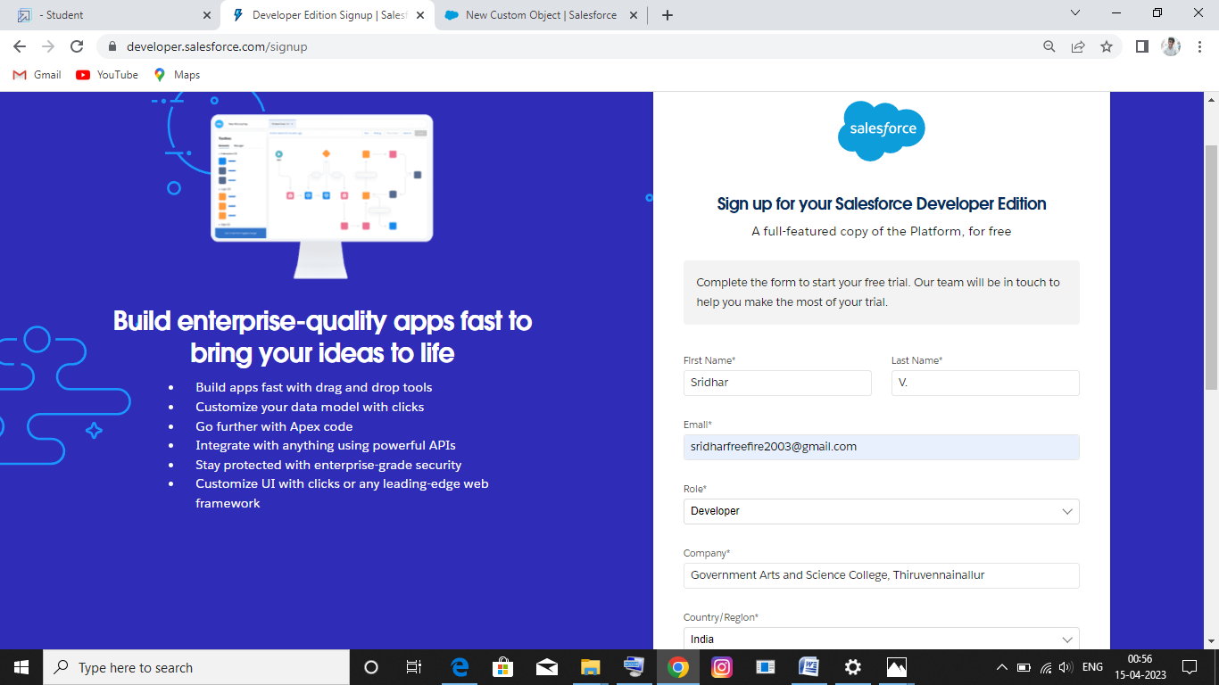

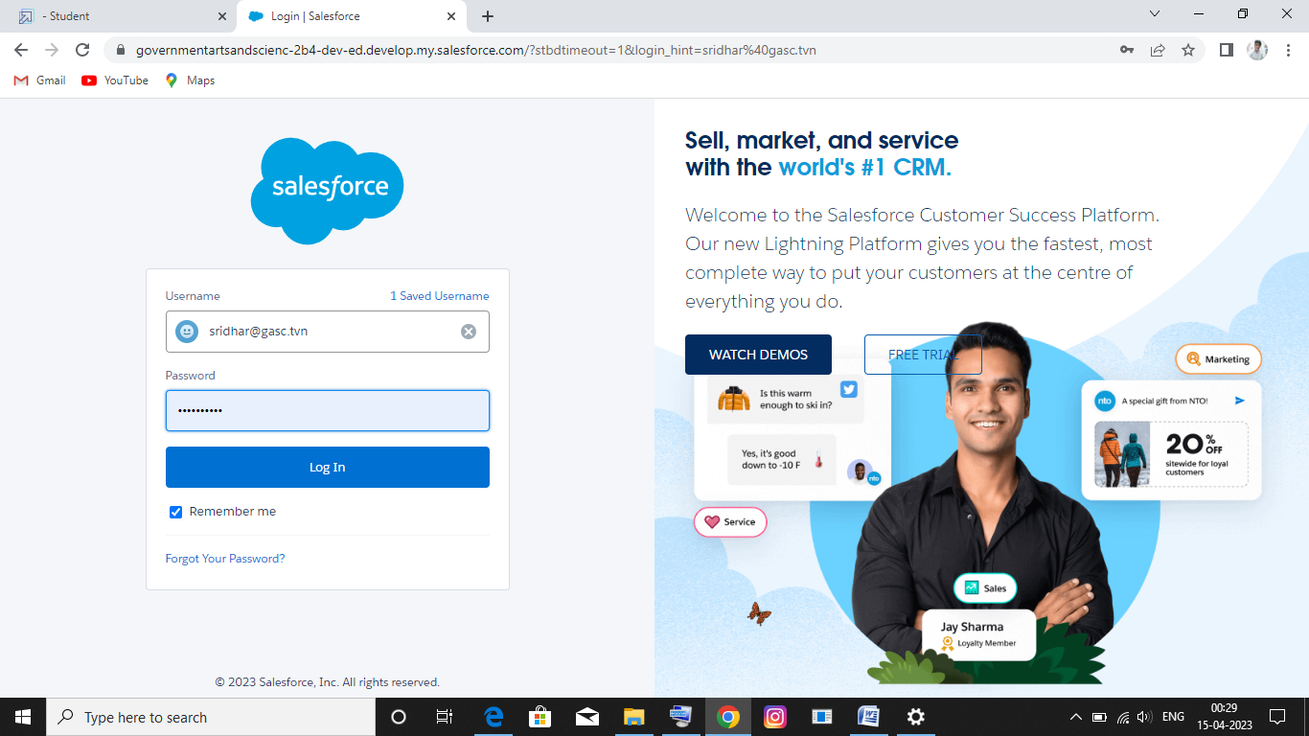

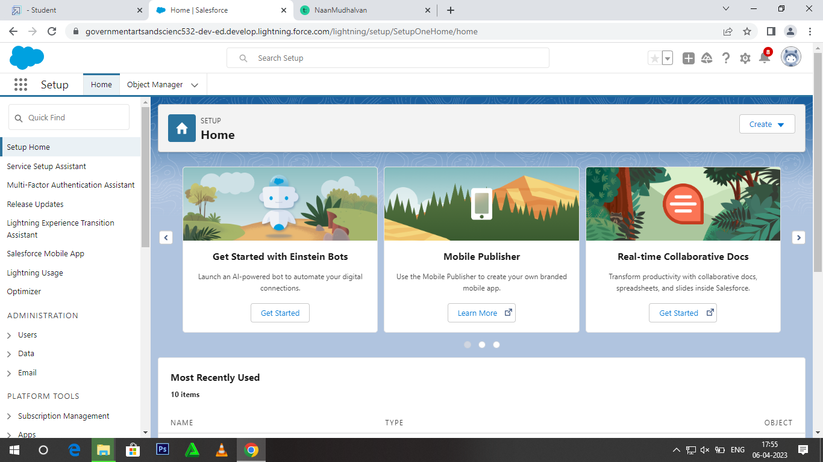

Milestone-2:

Custom objects: 1.Semester 2.Candidate 3.Course Details 4.Lecturer Details 5.Internal results

Activity-1

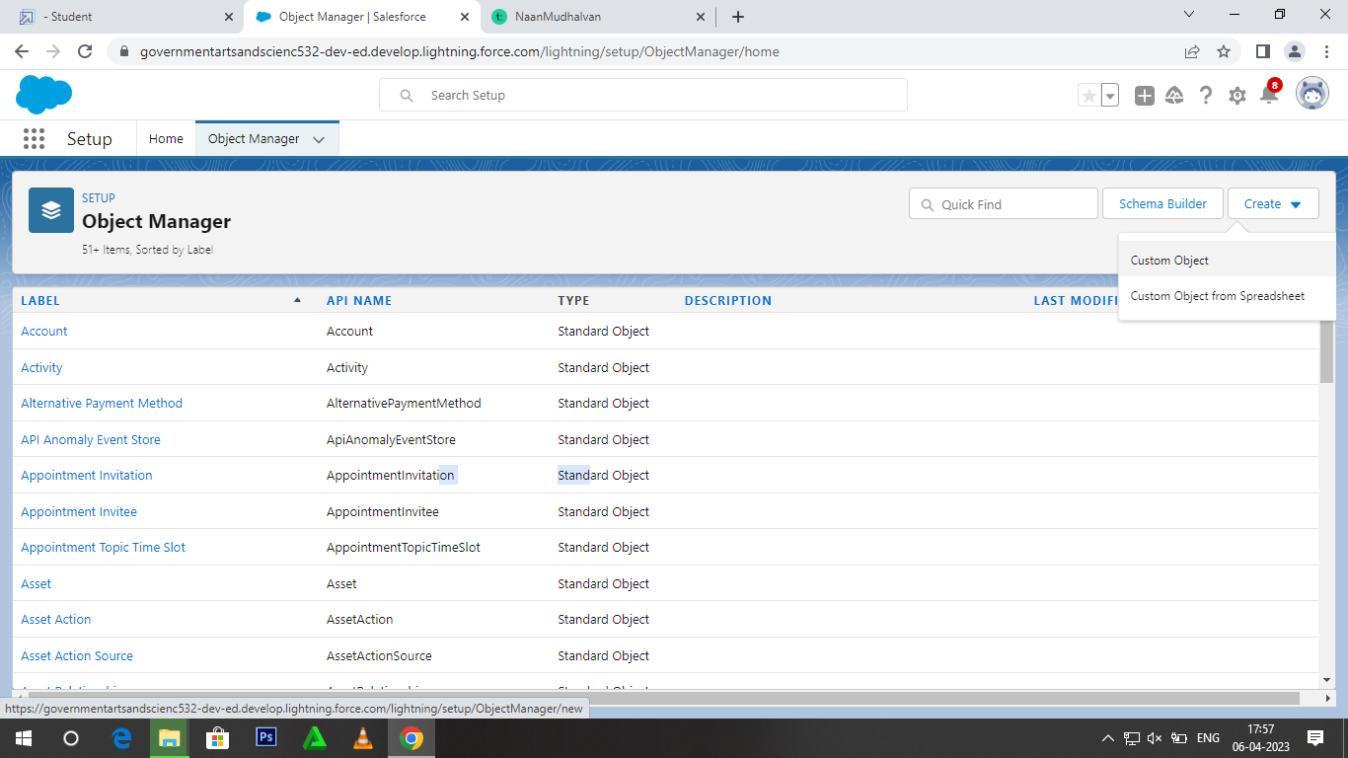

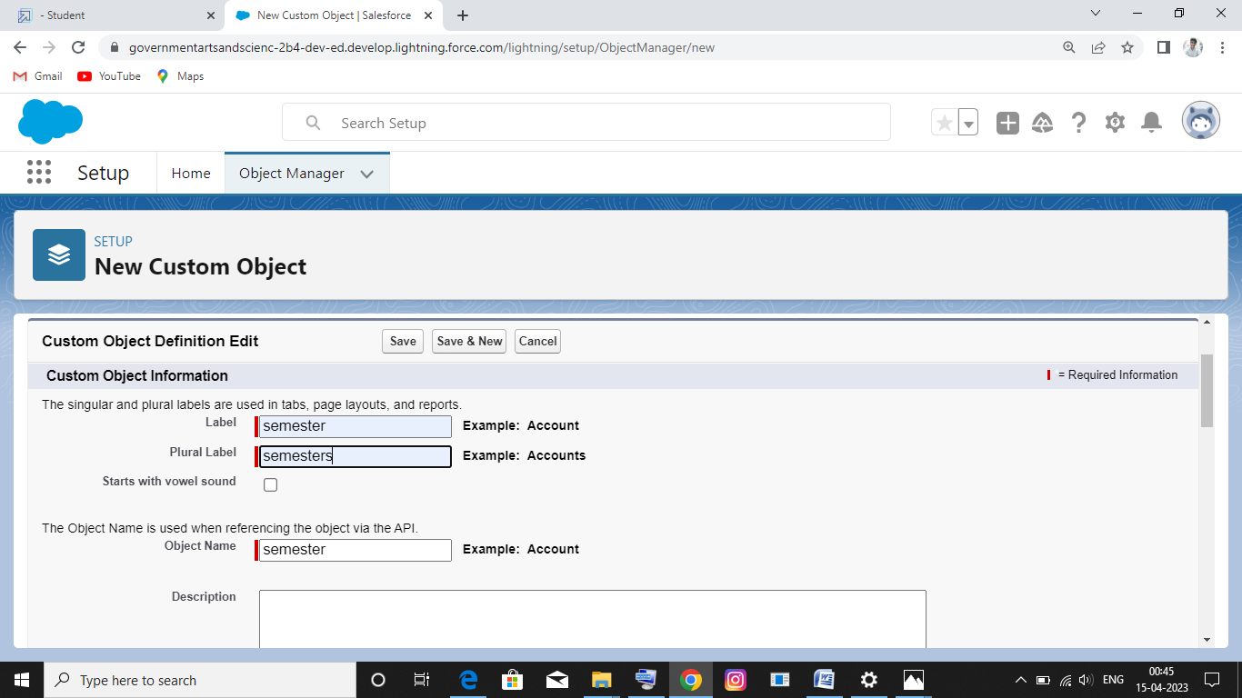

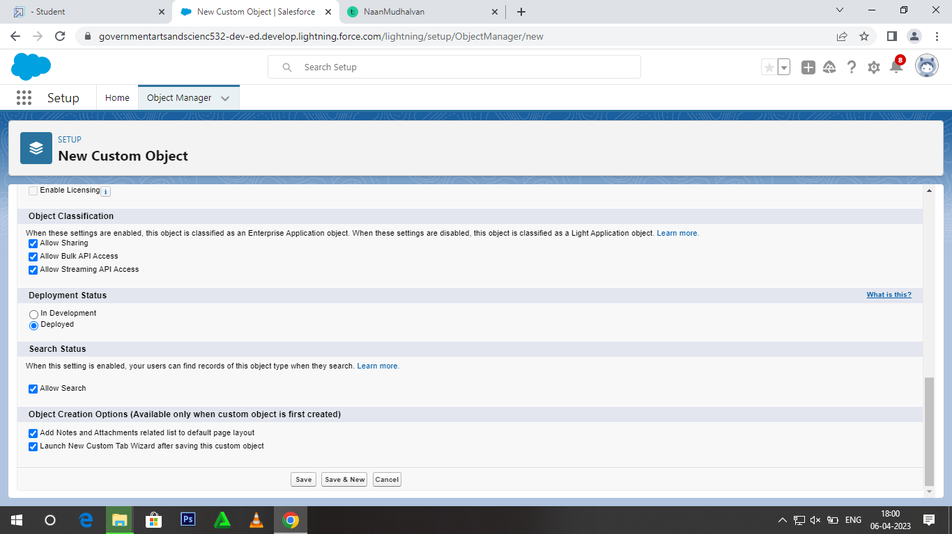

Activity-2

Follow Similar steps to create Candidate,Course Details,Lecturer Details,Internal results Objects.

Milestone-3: Fields and Relationship

Creation of fields:

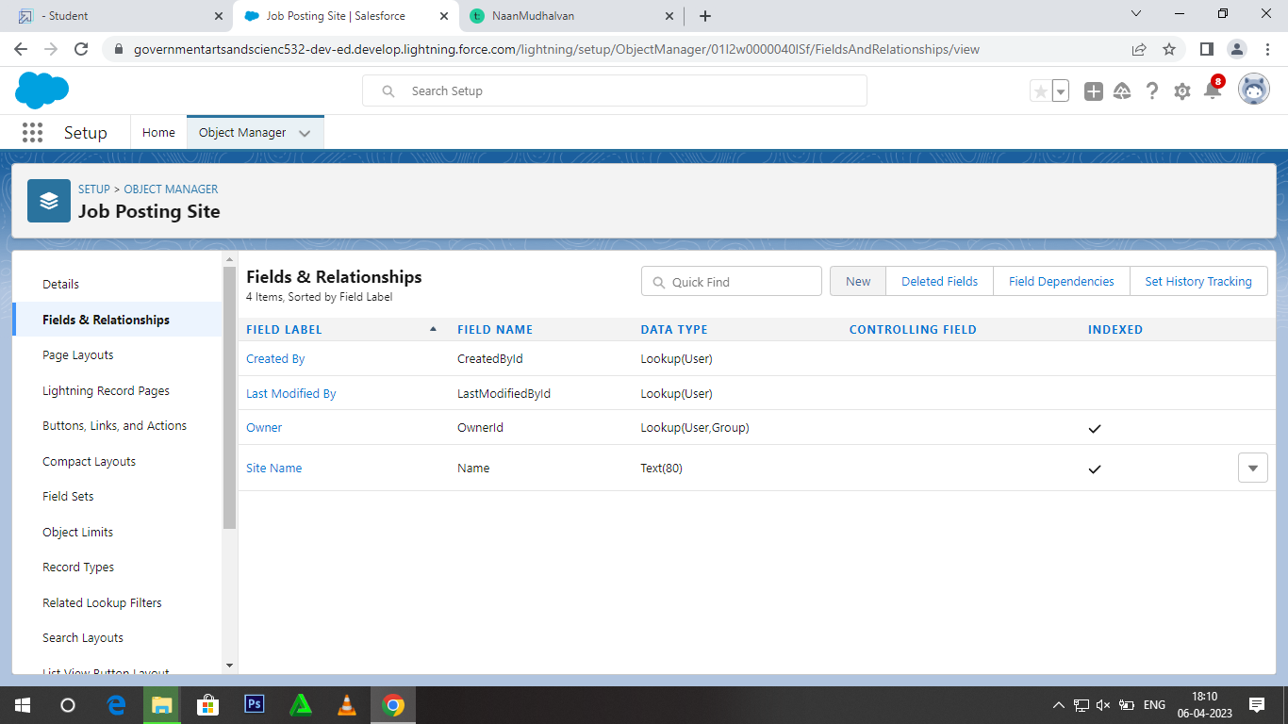

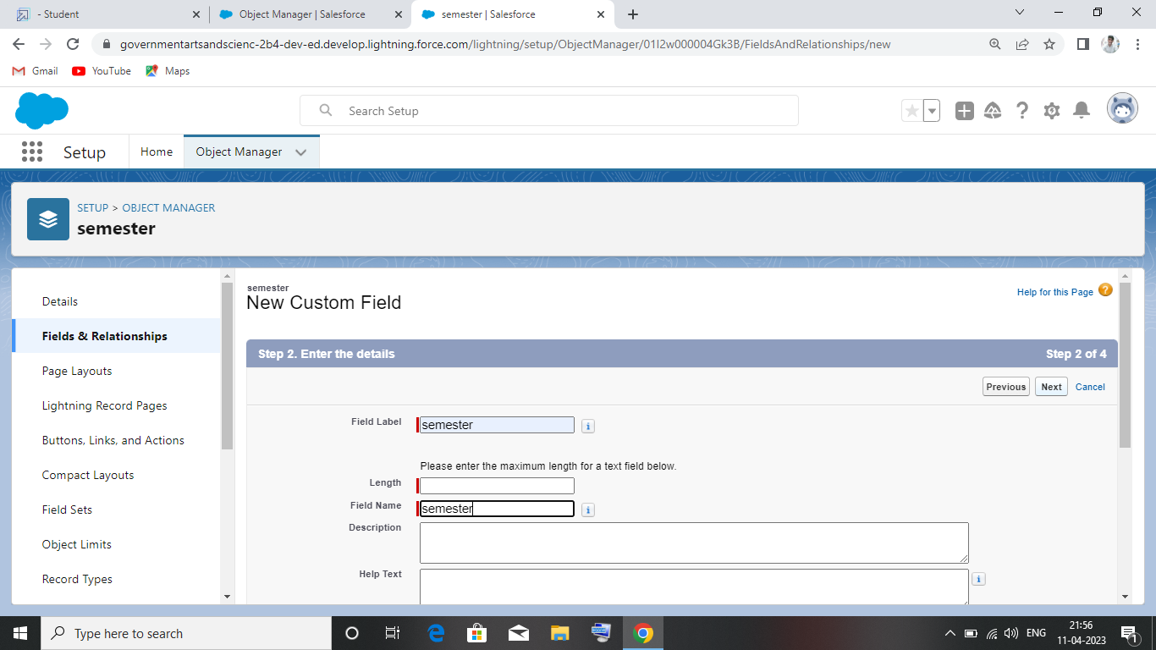

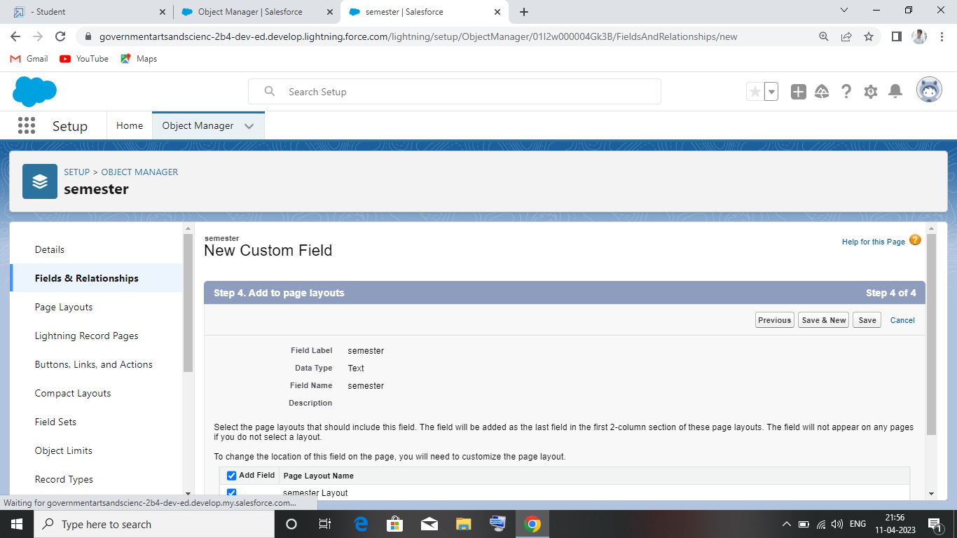

Milestone-4: Lightning App

Create the Candidate Internal Result Card app:

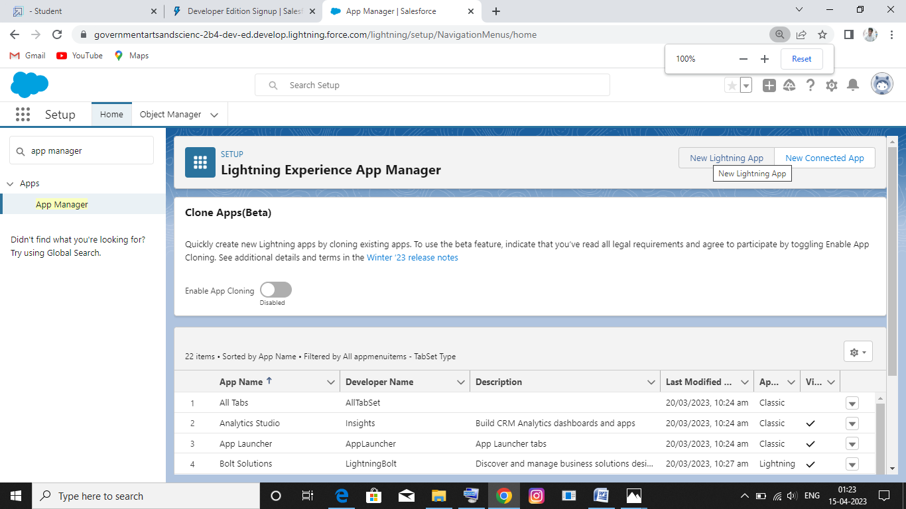

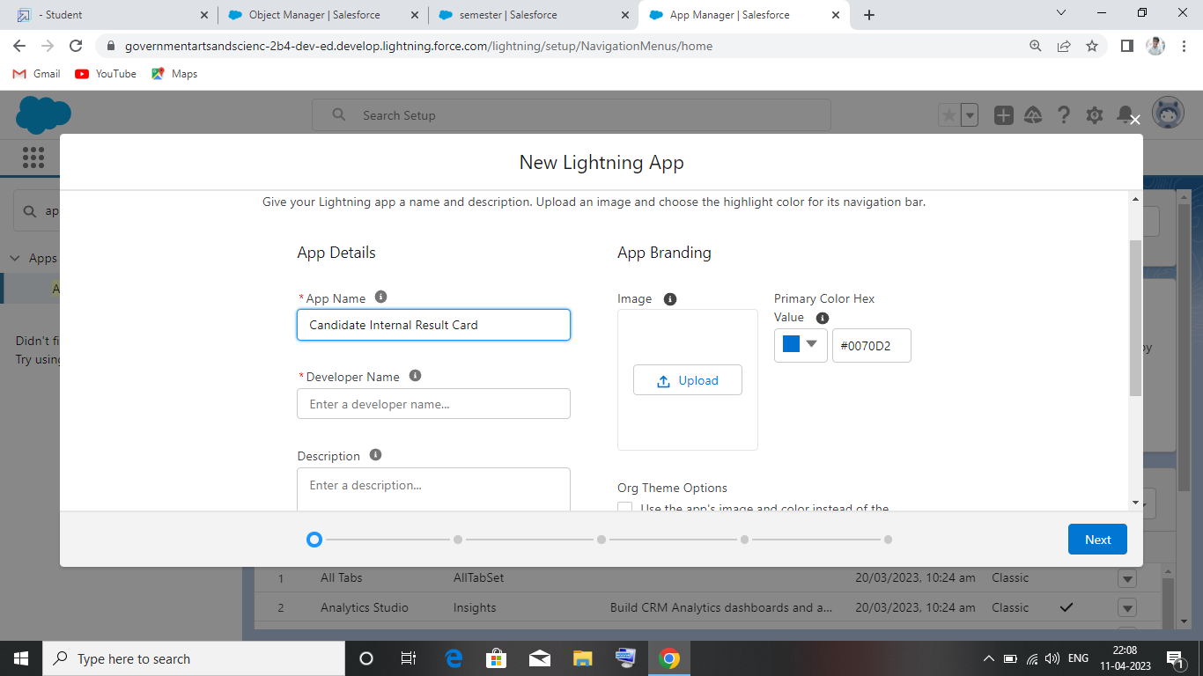

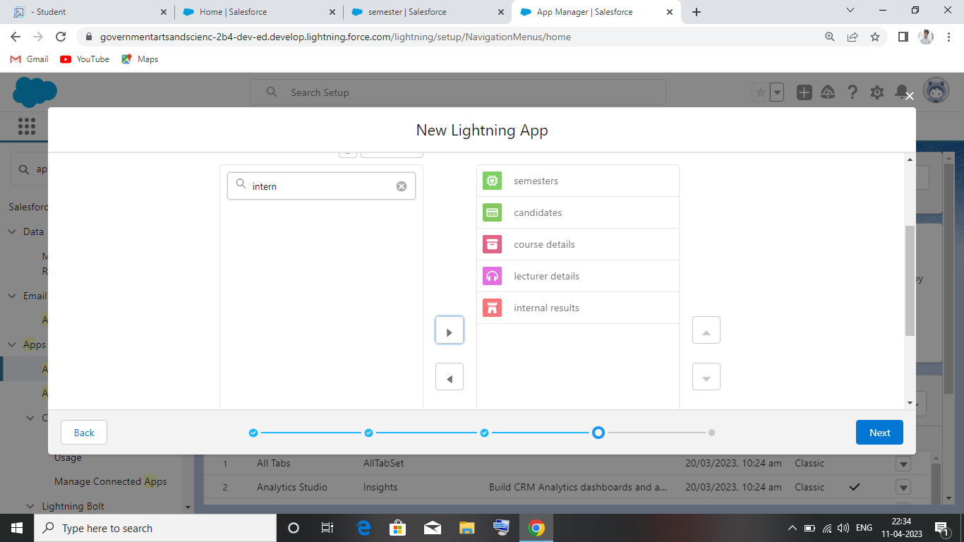

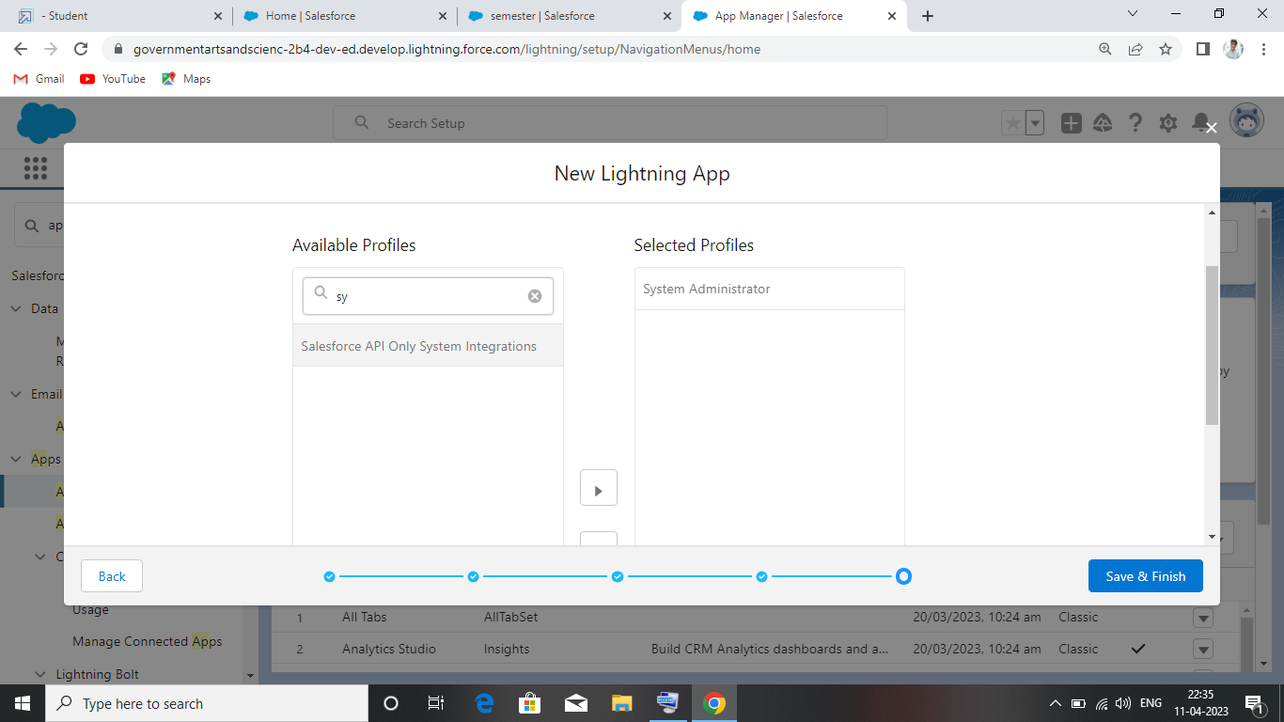

Mileston-5: Users

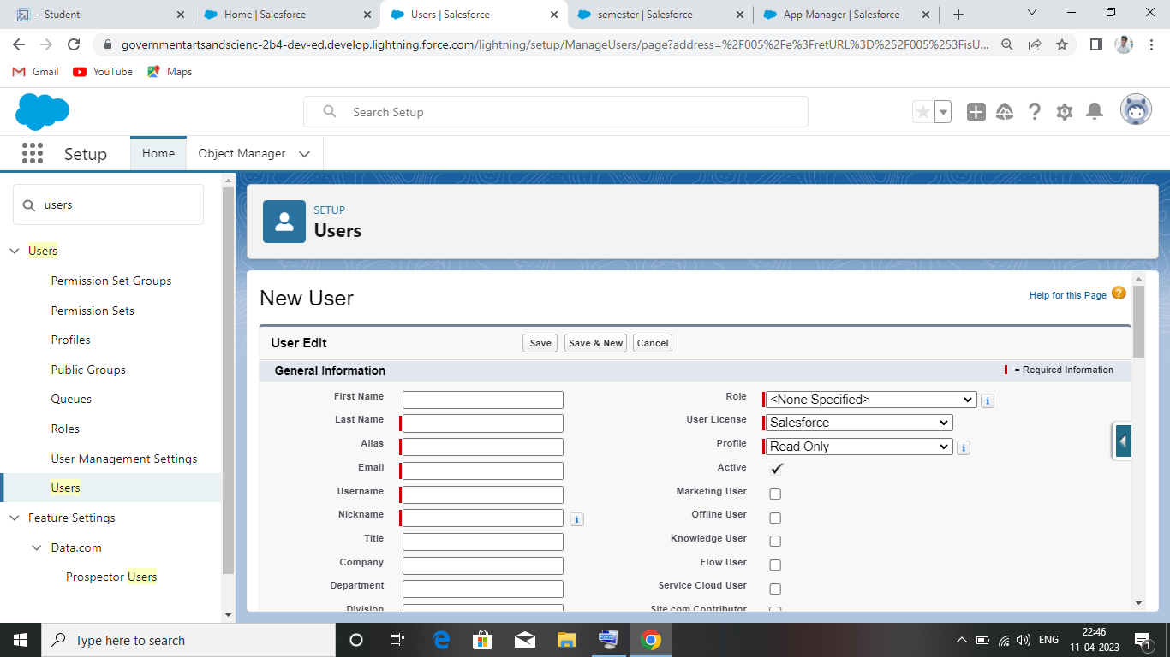

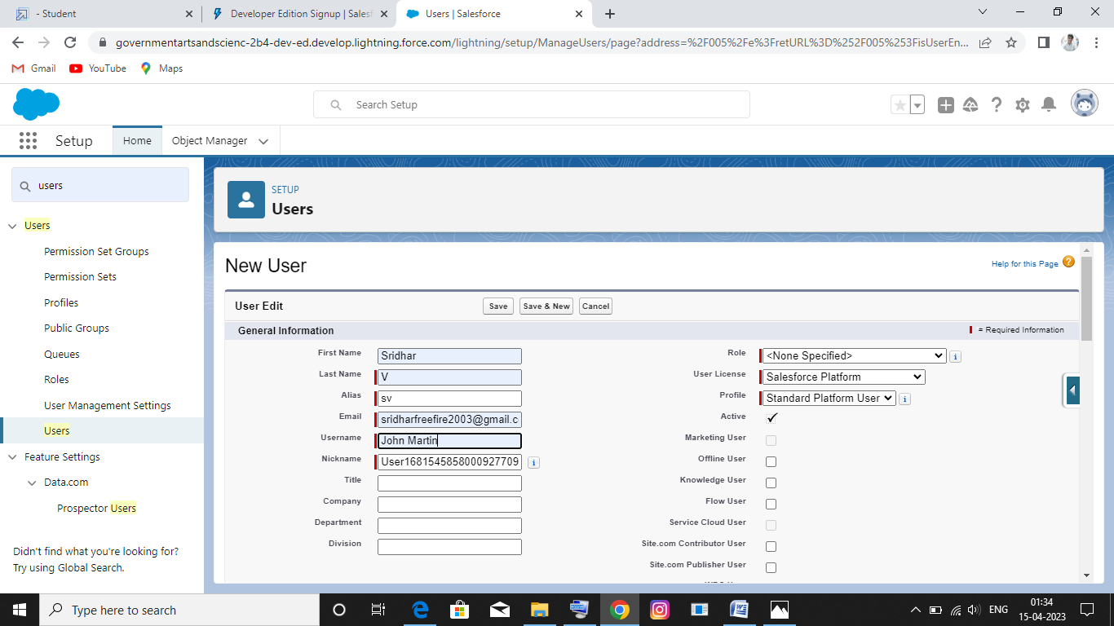

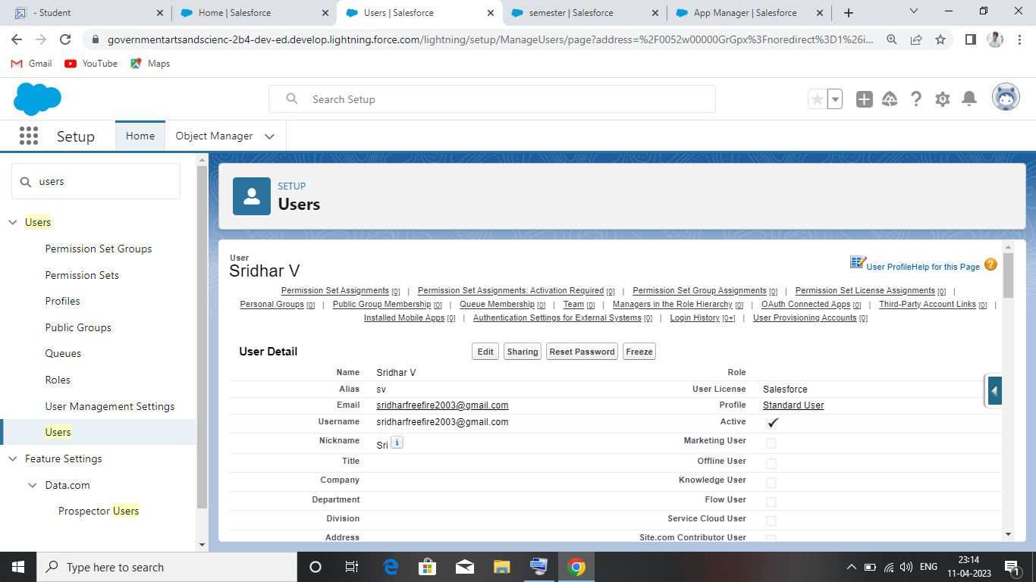

Milestone-6:Reports

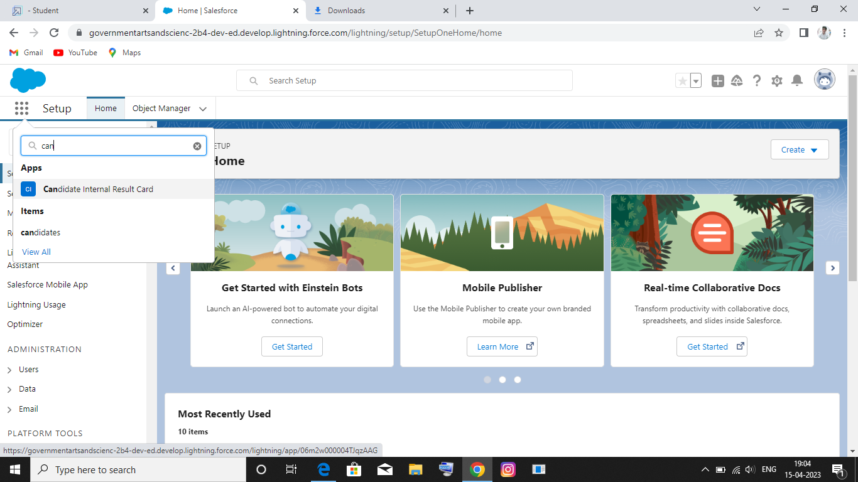

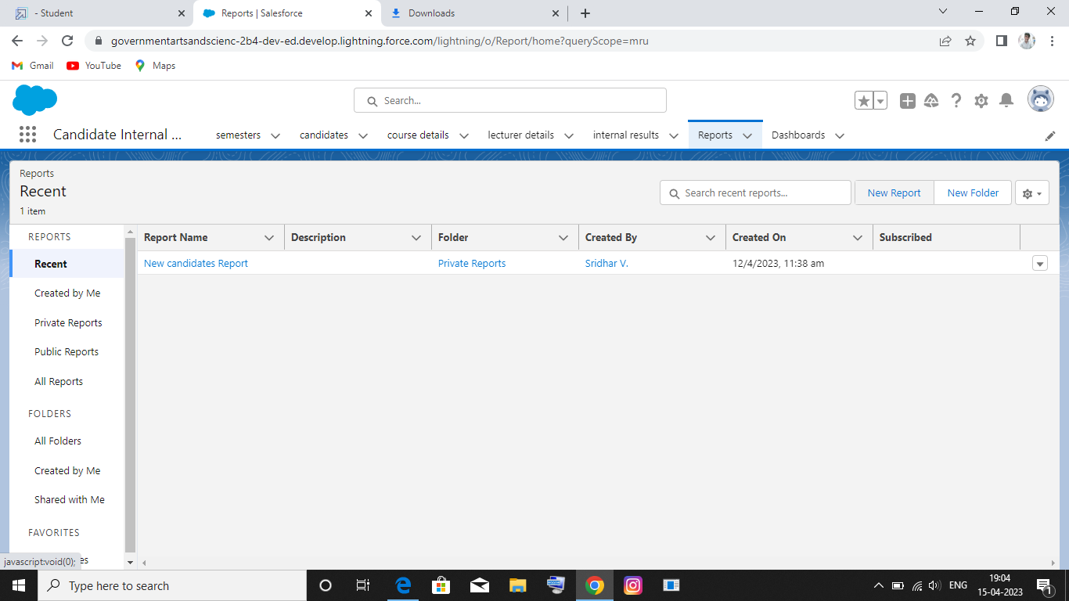

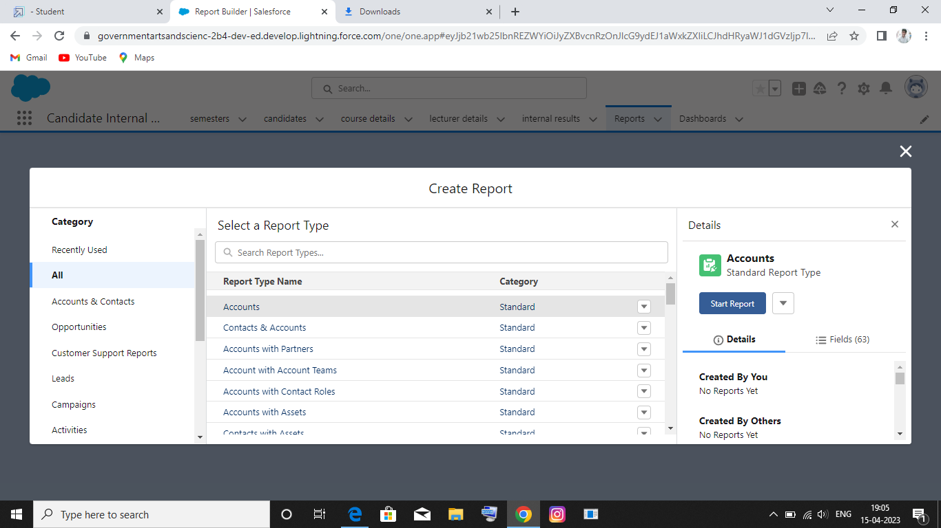

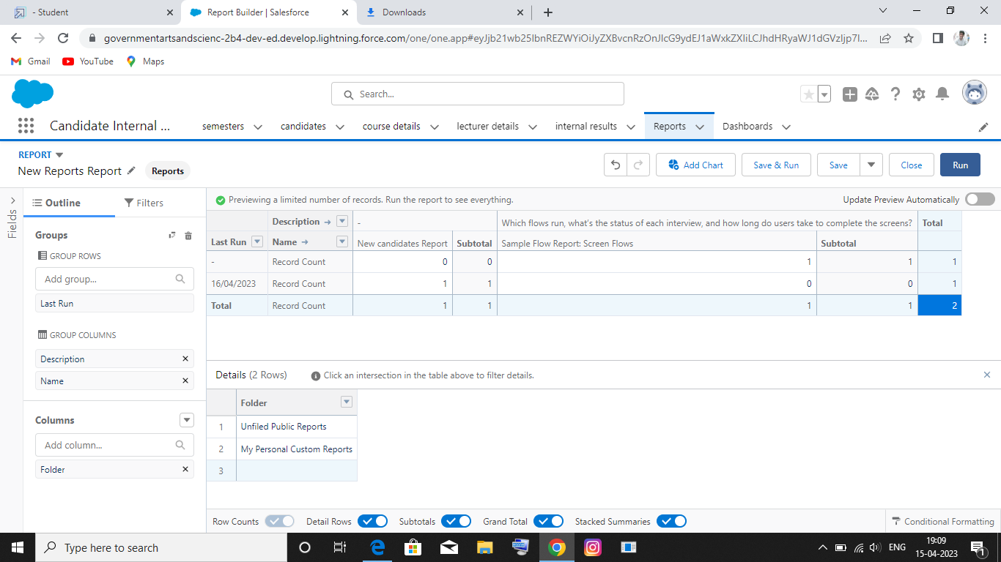

Milestone-7: Dashboards:

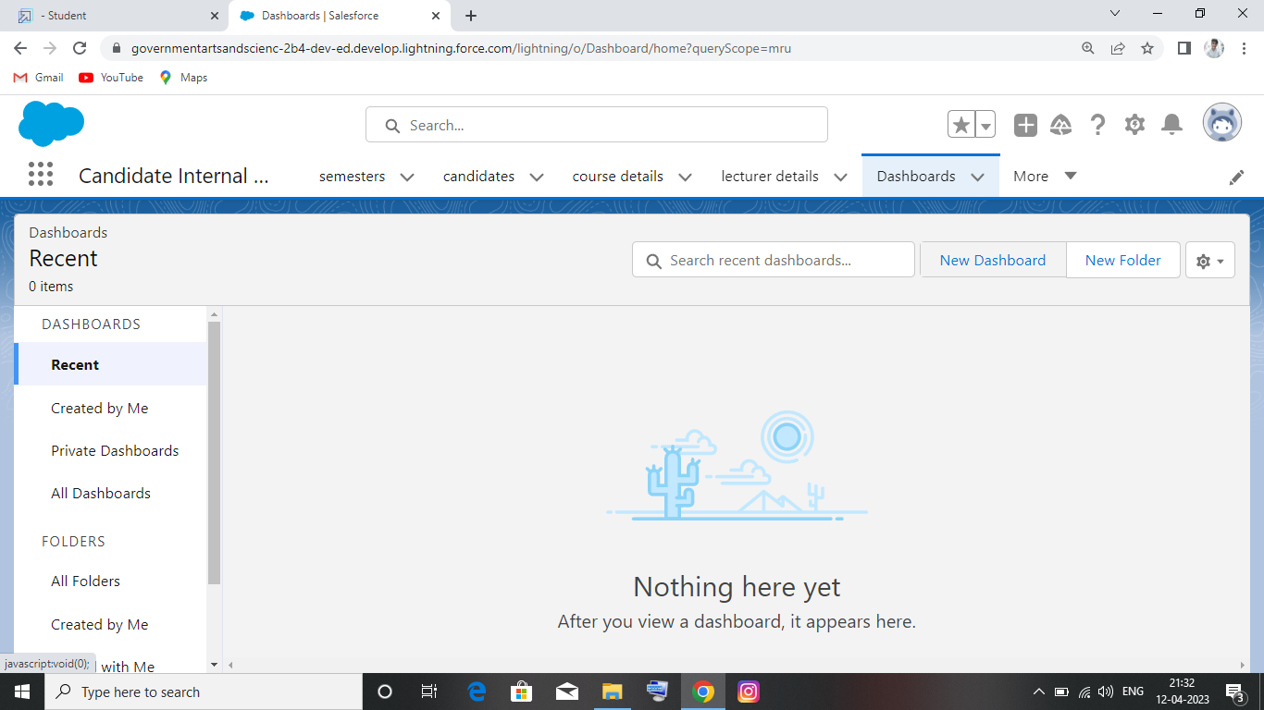

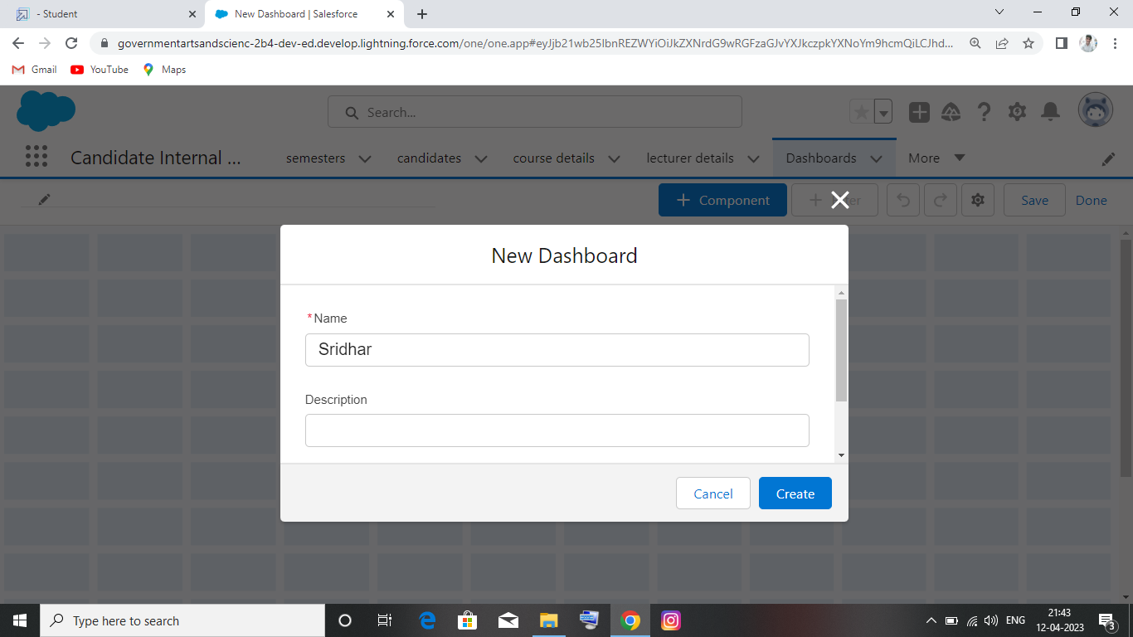

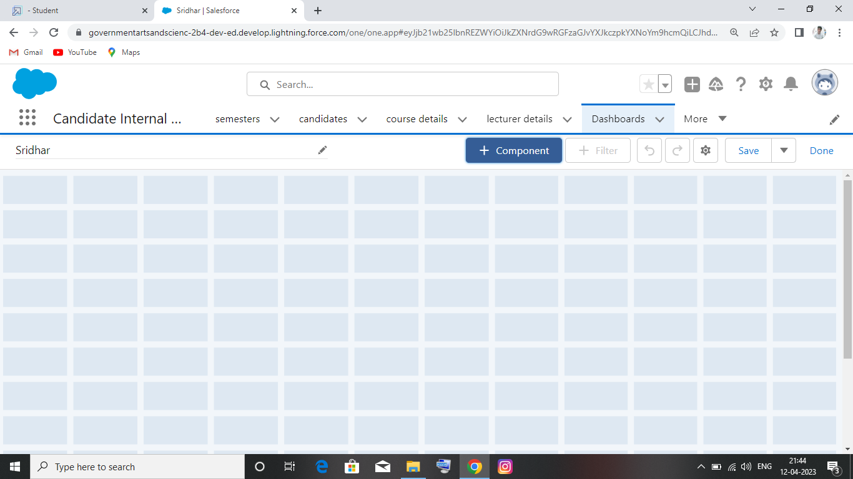

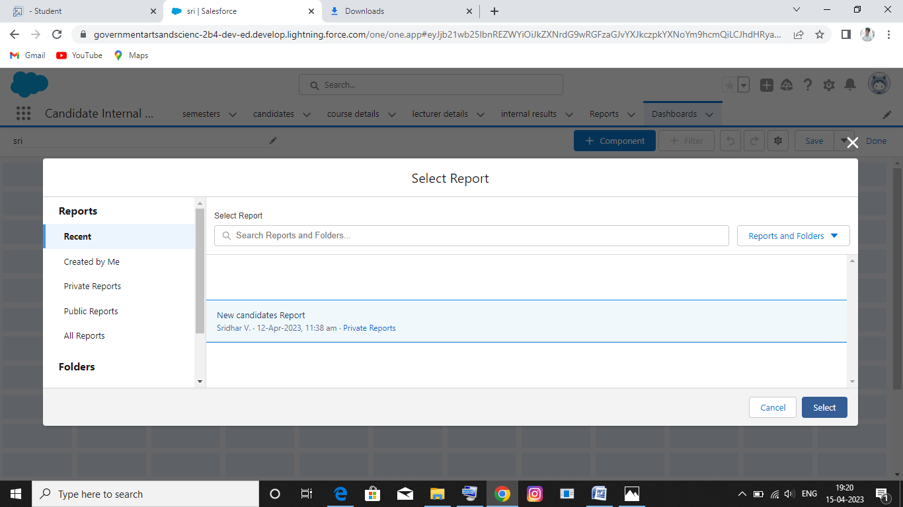

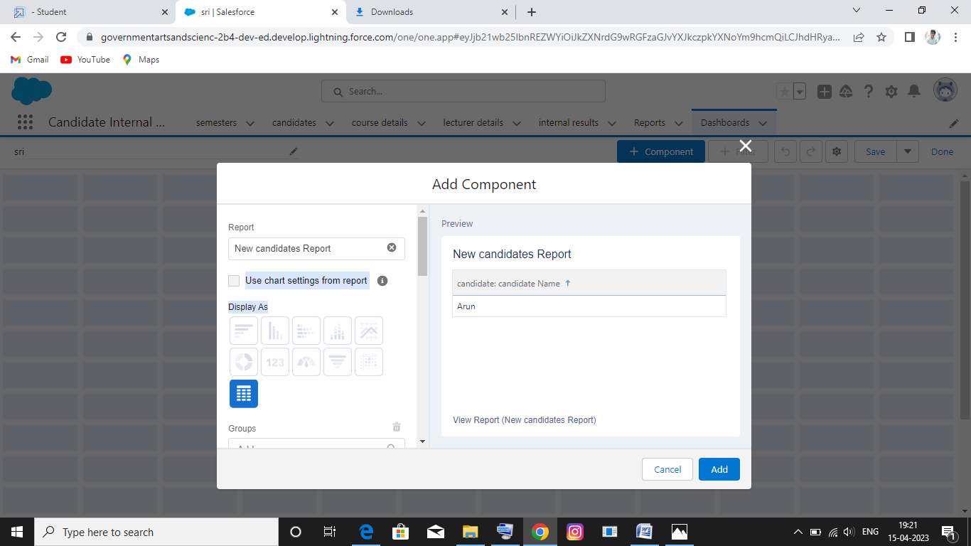

# 4. TRAILHEAD PROFILE PUBLIC URL

**Team Lead -** <https://trailblazer.me/id/sridv19>

**Team Member 1 -**<https://trailblazer.me/id/semmalaimalai>

# Team Member 2 - <https://trailblazer.me/id/sraman205>

# Team Member 3 - <https://trailblazer.me/id/rkumaran10>

1. **ADVANTAGES & DISADVANTAGE**

# ADVANTAGES

* It increase staff productivity, lowering time-cost.
* It allows geographically, dispersed teams to collaborate effectively.
* It allows for the consolidation of customer data and the basic for deep insights.
* Its speeds up the sales conversion process.
* Improves customer experience by allowing personalization and improved query resolution.

# DISVANTAGES

* Customer experience may worsen due to staff over reliance on the system.
* Security and data protection issues with centralized data.
* The excess initial time and productivity cost implementation.
* Requires a process-driven sales organization.
* CRM may not suit all business.

# APPLICATIONS

* I want something reliable.
* Target marketing.
* Increase candidate quality.
* Can work easily.
* Streamlining internal sales processes.

# CONCLUSION

Student Internals Mark Management System deals with student details, academic related

Reports, college details and course details. It track all the details of a student from the day one to the end of his course which can be used for all reporting purpose, tracking

of progress in the course, completed semester, upcoming semester details, exam details,

project or an other assignment details, and final exam result.

# FUTURE SCOPE

Scope of education means range of view, outlook, fields or opportunity of activity, operation and application of education. Education has wider and application .